Day 5: Lost in the Fog

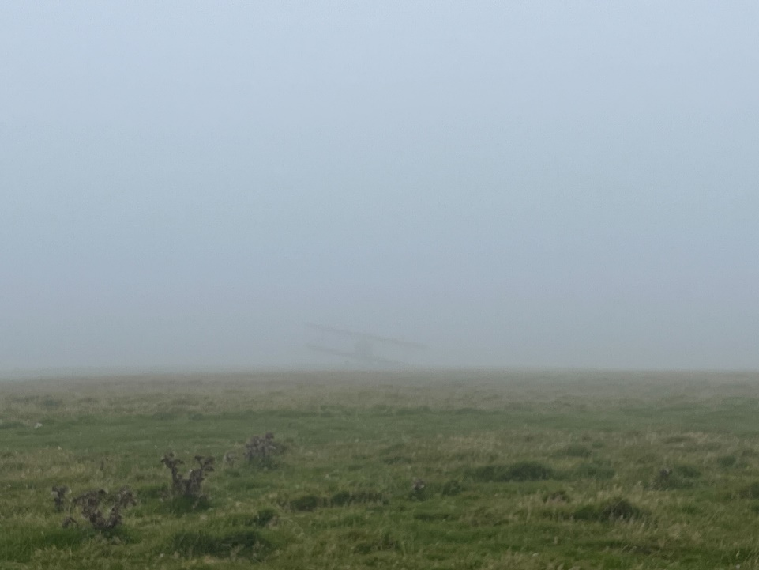

*For this photo Nick was stood in a field shrouded in a thick fog. At least it looks like there's an airport nearby. But what airport is it? It's not complex if you know how to look!*

*What is the ICAO code for the airport?*

For this challenge, I again had to retrieve the photo from the December 10 snapshot of the Wayback machine. Not a lot can be seen on the image, just a very faint airplane. Reading the accompanying text, I figure that I may be able to find relevant metadata. So, I download the picture and look at the properties. And I indeed find some coordinates: 51; 10; 13.08 lattitude and 4; 40; 0.12 longitude (rounded). In Google Maps, these coordinates take me to Nijlen in Belgium. Just a little bit to the north of these coordinates, I can see a helicopter on a field, that might be a clue for the proximity of the airport. When I search for ‘vliegveld’ nearby, I get the Antwerp International Airport and De Stunters, but both are not very close to the coordinates (5+ km). So, let’s see if there are any airports that are not indexed by Google Maps by searching for: vliegveld Nijlen. I get a hit for Nijlen Heliport, which explains the helicopter I saw on Google Maps. Although it is not an airport per se, we could try if this is the correct answer. The same Google search reveals the ICAO code as: EBNL. This seems to be incorrect. Perhaps the De Stunters airport is what we are looking for. However, I am unable to find an ICAO code for this airport. I am starting to think that the coordinates may be incorrect. I decide to look at the image using Forensically. In the Geo Tags tab, I am able to open the location in Google Maps, which brings me to a totally different place, called Lundy Island. The ICAO code for this airport was easily found:

**EGZV**.